cnc_wrwkcdshft

声明
/* write work coordinate shift */
[DllImport("FWLIB32.dll", EntryPoint = "cnc_wrwkcdshft")]
public static extern short cnc_wrwkcdshft(ushort FlibHndl, short a, [In, MarshalAs(UnmanagedType.LPStruct)] IODBWCSF b);

描述
写工件坐标。

参数
（1）FlibHndl 库句柄；[ in ]
（2）length
（3）wkcdshft [ out ]
/* cnc_rdwkcdshft:read work coordinate shift */
/* cnc_wrwkcdshft:write work coordinate shift */
/* cnc_rdwkcdsfms:read work coordinate shift measure */
/* cnc_wrwkcdsfms:write work coordinate shift measure */
[StructLayout(LayoutKind.Sequential, Pack = 4)]
public class IODBWCSF
{
public short datano; /* datano */
public short type; /* axis number */
[MarshalAs(UnmanagedType.ByValArray, SizeConst = MAX_AXIS)]
public int[] data = new int[MAX_AXIS]; /* data */
}

函数返回值
函数运行正常返回EW_OK。

代码
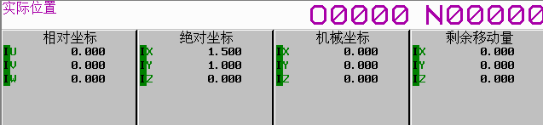
class Program
{
static void Main(string[] args)
{
ushort Flibhndl = 0;

short ret; // 返回值

// 获取库句柄 ( Ethernet )
ret = Focas1.cnc_allclibhndl3("192.168.0.224", 8193, 10, out Flibhndl);
if (ret != Focas1.EW_OK)
{
Console.WriteLine("发生异常，请检查！");
return;
}

#region cnc_wrwkcdshft

short length = 100;
Focas1.IODBWCSF wkcdshft = new Focas1.IODBWCSF();
//wkcdshft.type = Focas1.ALL_AXES;
//wkcdshft.data[0] = 1000;
//wkcdshft.data[1] = 2000;
//wkcdshft.data[2] = 3000;
wkcdshft.type = 1;
wkcdshft.data[0] = 1500;
ret = Focas1.cnc_wrwkcdshft(Flibhndl, length, wkcdshft);
#endregion
}
}

